I2C board Summary

Author: William Kerr

Designer: NCD.io

# Introduction:

I2C stands for Inter-Integrated circuit( more information can be found at <https://i2c.info>). It is a 2-wire interface that is used by many sensors. Specifically, all of our faculty sensors will be using this interface.

The I2C protocol has a master-slave architecture. In the I2C protocol, there is one master microcontroller (e.g. a Raspberry Pi) that is sending commands to all the slave devices connected to the I2C bus. The master calls a specific slave a command by sending a message through the I2C bus containing a command, and a slave address. The slave with that assigned slave address will respond with whatever the slave is programmed to do. Every slave device is assigned an 8-bit or 10-bit slave address from NXP, the designer of I2C.

In prototyping, I2C devices are wired up directly to the Raspberry Pi, and then communicated to directly. This I2C daughterboard will daisy chain all I2C sensors together. The I2C daughterboard attaches directly to the 40-pin Raspberry Pi pass-through header, so it won’t consume the entire 40-pin header, allowing for attachment of other 40-pin daughterboards. (e.g. a GSM module).

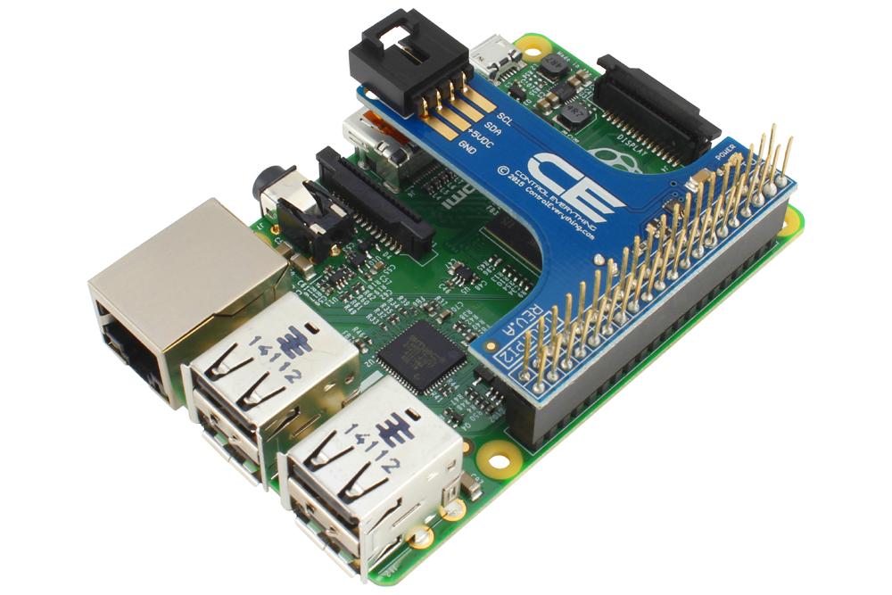

# Wiring Diagram:

Every slave device has two I2C ports: one to connect to the main board or the previous sensor, the other to connect to the next sensor that it requires.

Follow this handy wiring diagram for details:

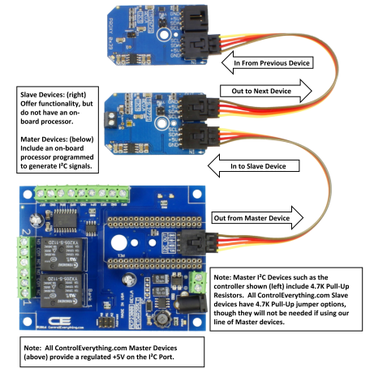

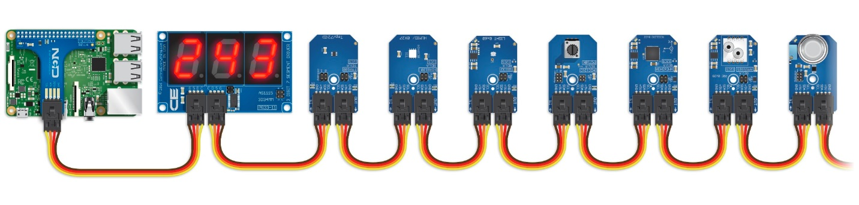

In theory, the main I2C daughterboard should have 4.7K pull-up resistors embedded inside. If not, I will have to design my own board that includes them, or order another board that has one.

The SI7020-A20 sensor is in stock at NCP.io, so I will use that sensor as an example.

# Sources:

## Male Molex Connector for soldering onto a board:

<https://store.ncd.io/product/i2c-interface-cable-nodelynk-connector-4-pin-male-molex-0705530003-wm4902-nd/>

## Main I2C Daughterboard

<https://store.ncd.io/product/i2c-shield-for-raspberry-pi-3-pi2-with-outward-facing-i2c-port-terminates-over-hdmi-port/>

## I2C Molex Cable

<https://store.ncd.io/product/i2c-cable-nodelynk-cable/?attribute_pa_length=6-inch>

## SI7020-A20 Humidity and Temperature I2C Module

<https://store.ncd.io/product/si7020-a20-humidity-and-temperature-sensor-%c2%b14rh-%c2%b1-4c-i2c-mini-module/>